RECKLESS TRAVELERS
BUSINESS PLAN

Prepared by:
Reckless Travelers LLC Headquarters
Mr. & Mrs. Sterling & Julian Crawford
P.O. Box 417
Fallon, Nevada 89407
Phone: +1-775-393-9040
Phone: +256-752-630302
Email: recklesstravlers@recklesstravelersbooking.com

https://www.recklesstravelers.com/
https://www.recklesstravlers.inteletravel.com
https://www.recklesstravelersbooking.com

Kampala, Uganda and Fallon, NV, USA

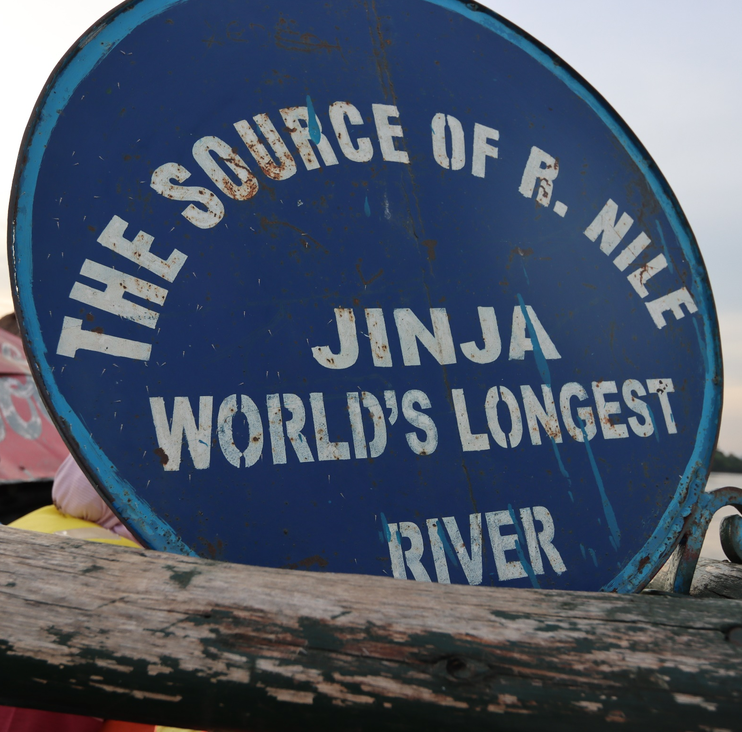

Table of Contents

Cover Page 1
Table of Contents 2
Reckless Travelers Marketing Plan For App Development 4
Google App 4
Apple App 5
Reckless Travelers Marketing Plan For Affiliate Programs 6
Expedia Affiliate Program 6
Booking.com Affiliate Program 7
Agoda Affiliate Program 8
TripAdvisor Affiliate Program 9
Amazon Affiliate Program 10
Hotels.com Affiliate Program 11
GAdventures Affiliate Program 12
Travelpayouts Affiliate Program 13
Kayak Affiliate Program 14
Viator Affiliate Program 15
World Nomads Affiliate Program 16
Get Your Guide Affiliate Program 17
REI Affiliate Program 18
Take Walks Affiliate Program 19
InsureMyTrip Affiliate Program 20
Trusted Housesitters Affiliate Program 21
Hostelworld Affiliate Program 22
Safety Wings Affiliate Program 23

Reckless Travelers

Public Information

I. EXECUTIVE SUMMARY

Reckless Travelers (referred to from hereon in as the "Company") was established as a Limited Liability Company at P.O B ox 417, Fallon, Nevada 89407 with the expectation of rapid expansion in the travel and travel services industry.

Business Description

The Company was formed on 03/29/2022 as Limited Liability Company under Nevada state laws and headed by Sterling D. M. & Julian Crawford.

Business Mission:

Reckless Travelers is a safe community for avid travelers to book travel, explore the forum and blog for all things travel. Stay up to date on

the latest travel gist, plan your journey, get sightseeing tips, and connect with other adventurers by way of providing a powerful search engine, travel booking tools, tour guides, and tour operators.

Reckless Travelers dare to travel the unbeaten path. By networking and sharing travel information, experiences and ideas, we

help one another plan safe and informed travel adventures to lands foreign and domestic.

New Service

The Company is prepared to introduce the following service to the market:

Travel booking Services: Whether travelers are privy to booking their own trips or requesting a travel expert plan and book their trip for them, we act as a one stop shop to getting travelers trips fully planned and booked at competitive prices across the industry.

Travel Consulting: Adventurers can gain essential information through the Reckless Travelers network by connecting with travel organizers, agents, and travel destination venues. Book travel by connecting with the founders and obtain important and useful information about traveling locally and abroad.

Merchandising: The public is free to access exclusive Reckless Travelers gear for purchase online to let the world know their interest in travel.

-Website renewal as of 8/8/2022.

The website is new. It is

Growth strategy phase

Analytics tools

Online marketing tools

User insights

Hours for online edits

Digital Marketing

Online Chat feature

G

Google App

Have submitted for approval.
Approved?: Yes
App Requirements: Completed
App Suggestions: None
App Developments: Improvements are underway. Trouble tickets submitted to Wix Development Team
Program Status and last update: May 7, 2023

Notes:
-The website requires a separate profile from the website itself. It’s as if all of the members who joined are required to create a new account.
- Update white pages on “About” page.
- Update bio for CEO
- Update bio for President
- Add “Book Now” button to top of all pages.
- Update “Resources” page.
- Redirect Contact submission form to automatically send email to recklesstravelers@recklesstravelersbooking.com

Apple App

Have submitted for approval.
Approved?: No
App Requirements: Resubmitted for review following Wix Developer updating Apple on requirements for approval.
App Suggestions:
Program Status and last update: May 7, 2023

Expedia TAAP

Expedia Affiliate Program

Have submitted for approval.
Approved?:
Program Requirements:
Program Suggestions:
Program Payouts:

Inteletravel Programs

Inteletravel Travel Advisor

Have submitted for approval.
Approved?: Yes
Program Requirements: Pass Courses

Program Suggestions: Update this page with IATA, CLIA, and various account info.
Program Payouts:

Big Red Jelly Affiliate Programs

Big Red Jelly Program

Have submitted for approval.
Approved?: Yes
Program Requirements: Website Refreshed
Program in place to keep the website up to date and fast
Optimize user experience

Program Suggestions:
Program Payouts:

Booking.com Affiliate Program

Have submitted for approval.
Approved?:
Program Requirements:
Program Suggestions:
Program Payouts:
Program Status and last update: May 7, 2023

Agoda Affiliate Program

Have submitted for approval.
Approved?:
Program Requirements:
Program Suggestions:
Program Payouts:
Program Status and last update: May 7, 2023

Amazon Affiliate Program

Have submitted for approval.
Approved?:
Program Requirements:
Program Suggestions:
Program Payouts:

How to Use the App

App User Suggestions and requirements: Upload content into the body of the post. Each post will come with a Title Section that must be used. The app will not let users move forward without completing the title section. Members must remember to only place media into the body of the content and not the Title section.

